Objectives 2024-25:

- To increase participation in both after school clubs and daily physical activity (DPA) within school.
- To provide a wider range and increased access to Level 1 and 2 competitions in a variety of sports.
- Pupils who need to increase activity levels are given the chance to participate against others of a similar ability and potential.
- To ensure that teachers have access to quality CPD and that teaching is of a high standard across the subject.



 | Action Plan 2024-25- 19,250 Spend
 | Focus and Impact on pupils | Actions | Action Notes | Impact Notes
Competition Level 0-4 | South Stoke Games organizer:  Level 2/3/4 Competitions  Cost = £50  Increased numbers of pupils competing in a range of L1 and L2 competitions.  Key indicator 2  Key indicator 4  Key indicator 5 | Children are to have the opportunity to take part in a wide range of competition, including indoor athletics and activities centered towards the less active. | Our aim is to ensure the high majority of children have participated in a level 2 competition before leaving Priory  Record competitions and participation | Children have taken part in over 20 events this year ranging from dance, gymnastics, cricket and football.  We had 50 children represent the school at Northwood with 15 representing Stoke schools in the City event.  Our Stoke team won overall against the rest oif the city.  We had gymnasts who competed in national competitions achieving a top 3 result.  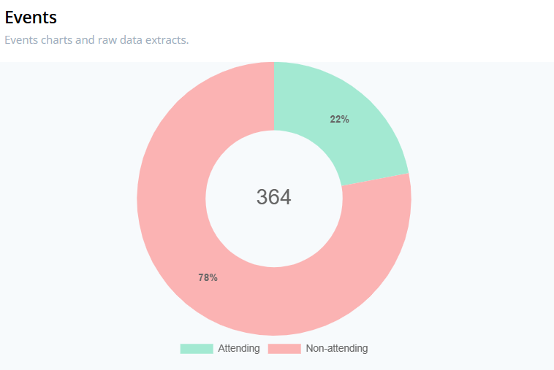  2024-25 year 3 and 4 need to be a priority as looking at the data from PE passport the high majority of the children who competed for the school are from upper KS2 (this is however due to how competitions are run).
Competition Level 0-4 | Level 0 and 1 competition integrated into school PE Curriculum Cost = £1000  Key indicator 1  Key indicator 2  Key indicator 5 | Each half term children will be working towards competing in Level 0 and 1 competition through their PE sessions. | For 2024-25 each year group aims to teach a unit and then compete in a level 1 competition applying those skills.  Monitor participation  Survey

 | Focus and Impact on pupils | Actions | Action Notes | Impact Notes
Subject Leader CPD | How much has your school spent on CPD internal learning and development?  Dance CPD for Staff and clubs  Cost = £12090  Increased confidence of staff to deliver high quality PE.  Increase number of pupils meeting national curriculum expectations and pupils benefit from lessons they enjoy and in which they make better progress.  Key indicator 2  Key indicator 3 | CPD for staff from reception to Y6  - Miss Forrester | Complete Staff audit  CPD regularly sent to staff, who pick and choose what then want to attend.  Monitor CPD evaluations from staff  Monitor impact in lessons | Miss Forrester has had a great impact across school for PE. She has supported teachers with their teaching of dance (a clear area of weakness from teacher voice).  She has helped the school compete in a range of dance competitions throughout the year. Teachers are now much more confident in the teaching of Dance as show by the Teacher voice feedback:  Staff have had CPD in planning using PE Passport; this has enabled the curriculum to be embedded through the school with a clear progression of lessons.  Staff have also used the assessment tool provided on PE passport to inform their overall judgements on arbor at the end of the year.
Subject Leader CPD | Teachers teach high quality PE which the children enjoy.  Apply training and make good use of resources.  Key indicator 1  Key indicator 2  Key indicator 3 | Curriculum imbedded through school with an ethos to push the children to help them become more active.  PE passport- see purchase in resources | Monitor participation in PE  Observe sessions

 | Focus and Impact on pupils | Actions | Action Notes | Impact Notes
Clubs | How much has your school spent on internal school based extra-curricular opportunities? 2500 More pupils will participate regularly in DPA. This in turn will improve health and performance levels.  Pupils from Reception to Year 6 will have access a range of school clubs.  Key indicator 1  Key indicator 2  Key indicator 3  Key indicator 4 | Miss Forrester to deliver a programme of daily extra-curricular activities  Staff to provide clubs for games- all year groups, netball, rugby, football (team), girls football all monitored by PE Passport | Monitor the take up by all pupil, gender and disadvantaged- use PE Passports to monitor | Key takeaways: an even spread across kS1 and KS2 in terms of number of children taking part. Boys and girls are also reasonably even.  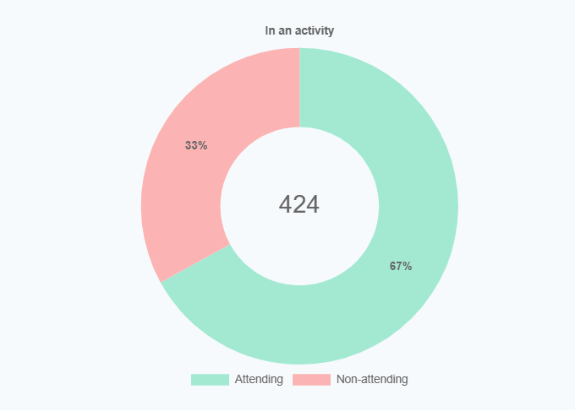  Clubs report gives more detail.

 | Focus and Impact on pupils | Actions | Action Notes | Impact Notes
Resources & Equipment | School based extra-curricular opportunities £200  Key indicator 1  Key indicator 2  Key indicator 4  Key indicator 5 | To facilitate children going to external events such as Cricket, football Northwood which all take place in the school day. | Record competitions and participation | Over 20 competitions completed with over 80 children taking part in level 2 coemptions across the school.
Resources & Equipment | PE Equipment  Equipment to be updated and regularly checked to ensure they are risk free.  Key indicator 1  Key indicator 2  Key indicator 5  Staff Time  Key indicator 1  Key indicator 2  Key indicator 4  Sports leaders and enjoyable lunchtime initiative  Increased opportunities for students to participate in structured activities at lunchtime and break time.  Key indicator 1,2,4 and 5  2450 | Teachers are to complete forms to clarify if any apparatus needs replacing and if they need any new apparatus to provide high quality sessions.  PE Passport £1000 purchased to support the planning, monitoring and teaching of PE  To maintain the standard of external gym equipment | Monitoring the quality of PE lessons and the use of resources.  Monitor impact of PE passport | Resources updated throughout the year- dance and gym equipment to support with competitions.  All resources up to date based upon the curriculum and needs of teachers.  Resources provided for lunch time staff- new goals acquired along with other resources to support more healthy and productive lunch times.
Resources & Equipment |  | To facilitate children going to external events such as Cricket, football Northwood which all take place in the school day. | Pupil survey on impact of equipment.  Random observation/ count on use of equipment – rough % of children who use the areas. | Resources updated throughout the year- dance and gym equipment to support with competitions.  All resources up to date based upon the curriculum and needs of teachers.  Resources provided for lunch time staff- new goals acquired along with other resources to support more healthy and productive lunch times.
Resources & Equipment |  | Sports leaders to complete young sports leaders programme and support delivery of lunchtime and afterschool activities. | Work closely with lunch time staff.  Pupil survey on impact of equipment.  Take up in activities- monitor.
Resources & Equipment | Please note that this year swimming will be £6600 provided from the schools’ core budgets- this facilitates expectations within the National Curriculum- see swimming results
Resources & Equipment | 