Policy on Behaviour, Communication and Relationships Policy

Behaviour Leaders: Jenny Cunliffe, Emma Woolliscroft and Lee Facey
Inclusion Leads Emily Woodroffe, Kerry Forrester and Sheridan Forrester

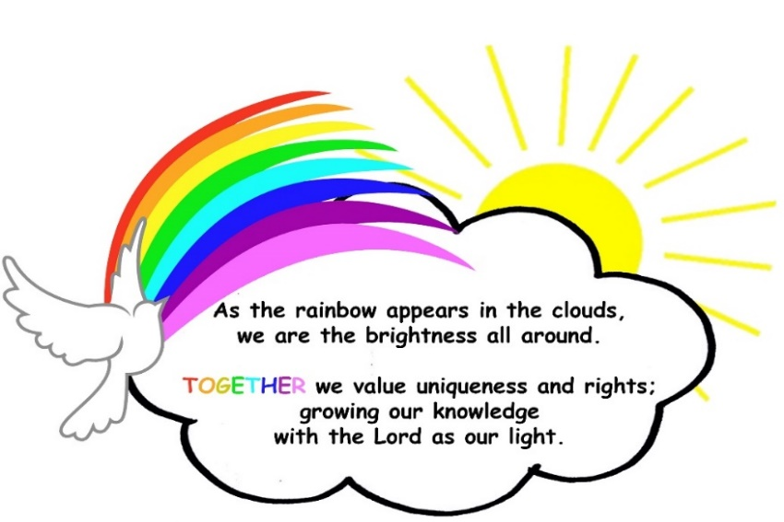
1. Rationale
At Priory, our strong vision and values, along with our distinctive Christian character and Right Respecting ethos are at the heart of all we do. We pride ourselves on our culture which celebrates individuality, personality and talent and supports the creation of respectful, resilient minds, ready for the world. We believe in respecting and celebrating diversity and supporting every child as a unique individual. We give children a strong voice and teach them to use this to be responsible, respectful citizens who can make a positive contribution to their community and beyond.
Our children value and respond positively to our school community and on the whole they conduct themselves well and demonstrate respect for the rights of others. They also understand that some behaviour choices such as bullying, harassment and violence are not acceptable. Sometimes pupils need support with behaviour regulation. Our system values all of God’s children and comes from a trauma sensitive point of view, with respectful and consistent relationships at the heart. Emotion coaching ensures that our children feel validated and supported. If there are any incidents we always use ‘Restorative Practice’ and children have a good understanding of making things right and having a fresh start.

SIAMS Inspection 2022
“The ethos permeates the school through character development, relationships, behaviour and attitudes. It ensures that pupils adopt a clear understanding of right and wrong and the impact of everyone’s choices. Consequently, pupils unfailingly behave calmly, courteously and with dignity. They show their immense loyalty to each other and the school. Forgiveness and reconciliation come naturally and are well-established in the environment of deep mutual respect. Bullying of any type is very rare, but when disagreements do arise, relationships are swiftly and effectively restored”.

It is imperative that parents and carers work with us to promote positive behaviour and relationships. Our Home
School Agreement sets out what all of us should be able to expect from each other. We understand that factors
outside school can influence behaviour and we appreciate being made aware of any circumstances which may have an impact. It is always in the children’s best interests that we work together as a team.

2. Aims
- To work TOGETHER with God to be the best that we can be
- To respect and uphold the rights of everyone
- To ensure a consistent approach to behaviour regulation
- To establish a safe, orderly and positive environment where pupils flourish
- To support pupils to take responsibility, to recover and repair following any incidents
- To encourage and support self-regulation and co-regulation
- To be trauma sensitive at all times.

This policy complies with Section 89 of the Education and Inspections Act 2006.

3. The Importance of Relationships

At Priory, we understand that relationships between staff and pupils as well as between pupils play a crucial role in the personal development of the children that we serve.

Here are some key points explaining their importance:
Emotional Security
Strong, positive relationships with teachers, peers, and family members provide children with a sense of emotional security. This stability helps children feel safe and supported, which is crucial for their willingness to engage in learning and take risks in the classroom.
Social Skills Development
Primary education is a pivotal time for developing social skills. Through interactions with peers and teachers, children learn essential skills such as communication, cooperation, empathy, and conflict resolution. These skills are foundational for their future relationships and success in collaborative environments.
Academic Achievement
Positive relationships with teachers are linked to higher levels of academic achievement. When students feel valued and understood by their teachers, they are more motivated to participate in class, complete assignments, and strive for excellence. Teachers who build strong relationships with students can better tailor their teaching methods to individual needs, further enhancing learning outcomes.
Behavioural Development
Good relationships help in managing and guiding children's behaviour. Teachers who establish a rapport with pupils can more effectively implement classroom management strategies and address behavioural issues in a supportive manner. Students are more likely to follow rules and exhibit positive behaviour when they respect and feel respected by their teachers.
Mental Health and Well-being
Strong relationships contribute to better mental health and overall well-being. Children who have positive interactions with peers and adults are less likely to experience anxiety, depression, and other mental health issues. These relationships provide a support system that helps children cope with stress and challenges.
Engagement and Motivation
Relationships with peers that are built on mutual interests and respect can enhance engagement and motivation. Group work and collaborative projects become more effective when students have positive relationships, making learning a more enjoyable and dynamic process.
Role Modelling
Teachers and peers serve as role models. Positive relationships allow students to observe and emulate good behaviour, attitudes, and work ethics. This modelling helps children develop a sense of responsibility and understand the importance of building and maintaining good relationships.
Parental Involvement
Relationships between teachers and parents are equally important. Effective communication and collaboration between parents and teachers can enhance a child's learning experience. When parents are involved and informed, they can reinforce learning at home and provide additional support.
Lifelong Learning Attitude
Positive early relationships can instil a love of learning. When students associate learning with positive experiences and relationships, they are more likely to develop a lifelong passion for education and personal growth.
Conflict Resolution and Problem-Solving
Through interactions with others, children learn how to navigate conflicts and solve problems. Positive relationships provide a safe environment for practicing these skills, which are essential for personal and professional success later in life.
At Priory, we believe that relationships are fundamental to primary education as they influence emotional,

social, and academic development. By fostering positive relationships, educators can create an environment that supports holistic growth, preparing children for future challenges and opportunities.

4. TOGETHER Values
Our TOGETHER Values are the heart of all we do, ensuring that we provided a values-based education, which allows all pupils to flourish.
A values-based education ensures that we can provide:
- Opportunities for Spiritual Development – Values-based education fosters spiritual growth by integrating Christian values into the curriculum and daily activities. It encourages pupils to reflect on their beliefs, which inform their actions and decisions.
- Moral and Ethical Foundation – Values-based education provides a strong moral and ethical framework, rooted in Christian teachings, By emphasising values such as honesty, trust, gratitude and respect, pupils learn to make ethical decisions and develop a sense of right and wrong, which guides their choices both inside and outside of school.
- Community and Social Cohesion – Values-based education encourages pupils to respect and value diversity, fostering a sense of belonging and mutual respect. This is essential in creating an inclusive school environment, where all pupils feel valued and supported.
- Academic Achievement – When pupils learn in an environment that promotes positive values, they are more likely to be engaged, motivated and focused. This supportive atmosphere can enhance their overall learning experience and academic outcomes.
- Personal Development – Values-based education helps in the holistic development of pupils; focusing not just on academic skills, but on personal growth. It encourages qualities such as resilience, empathy, and self-discipline, which are vital for personal success and wellbeing.
- Preparing for Future Challenges – By instilling strong values, pupils are prepared to face future challenges with integrity and confidence. The values they learn, provide a strong foundation that helps them to navigate complex social, moral and ethical issues that they may encounter in their lives.
- Role Models – Our staff serve as role models of Christian values. This modelling is crucial, as pupils learn by observing the behaviour and attitudes of the adults around them. The consistent demonstration of the school values reinforces their importance and impact.

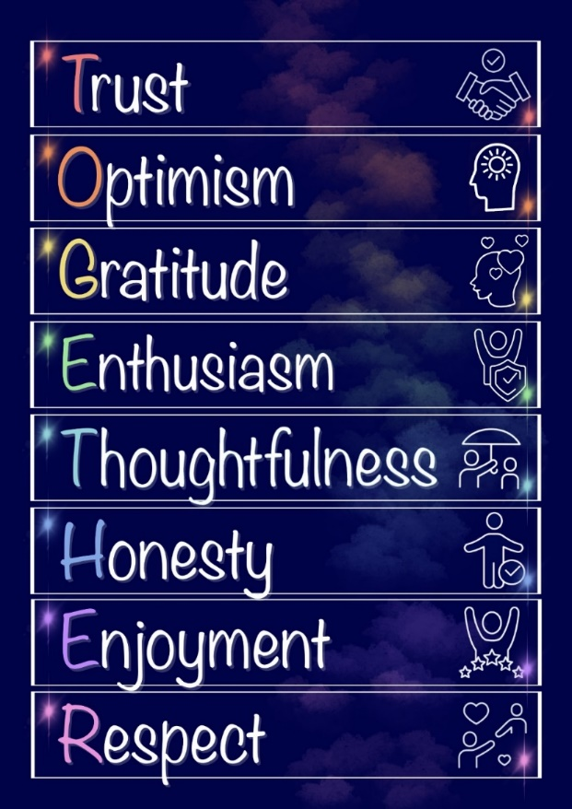

5. Rights and Responsibilities
As a Rights Respecting (RRS) school, we explicitly teach and make reference to the rights of children. We have selected five key rights to focus on in school. We promote individual and collective responsibility to ensure that these rights are respected by all. To encourage pupils to take responsibility for upholding rights, some examples are suggested below. We ensure pupils understand that a failure to support the rights of others does not lead to a removal of their own rights.

At the start of every year, we teach the main five rights and children sign up to the Class Charter which is then displayed in the classroom. These rights and responsibilities are then reinforced in class and through worships.

Priory CE Primary Rights (suggested responsibility)

1. We all have the right to be safe and healthy (To share ideas and listen to others)

2. We all have the right to join in lots of activities, play and relax (To be kind, caring and supportive)

3. We all have the right to any special care and support we need (To look after ourselves, each other and our school)

4. We all have the right to develop our own personality and talents (To always try hard and encourage each other to be the best that we can be)

5. We all have the right to help make important decisions (To take part, play fair and include others)

6. Secrets of Success
We teach the children to be successful and reflective learners with a growth mindset. We teach this through Chris Quigley’s Secrets of Success. These secrets help our children in their behaviour, attitudes and values. Each of these secrets has a dojo character attached to it.
The 8 Secrets of Success are:
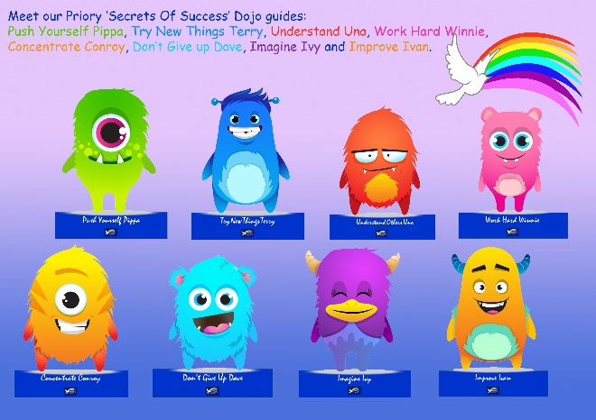
- Try new things
- Work hard
- Concentrate
- Push yourself
- Imagine
- Improve
- Understand others
- Don’t give up

7. Rewards
TOGETHER Rewards
We want the children to have a sense of achievement and to understand that they receive rewards for demonstrating our values and making good choices and therefore, ‘being the best that they can be’. We aim for a 6:1 ratio of rewards to sanctions. Rewards we give include smiles, public and private praise, table/class rewards, star of the day/week, individual dojos, as well as awards in worship.

Any member of staff should be in the position to award a TOGETHER Dojo at any time during school hours. The number of dojos given at any one time should be limited to 1, unless the school is having a particular focus and then this will be added to the Dojo system by a member of SLT.

Each pupil has a card holder. The aim for the year is to earn 20 values points for each of the TOGETHER values. When they reach 20, they will receive a value card to be placed in their card holder. They can also earn ‘Be the best that you can be’ points. They will receive a bronze, silver and gold card for their collection with each 100 points. All pupils will be able to take home their card holder and rewards at the end of the year.

Children in the Early Years will earn ‘Be the best that you can be’ points, but the language of our school values will be introduced in order to begin to develop the vocabulary and understanding of values. For example, ‘You have earned a Be the Best that you can be point for being Thoughtful.’

Class/table rewards
Individual classes have adopted systems whereby groups of children work together in a cooperative manner to achieve a common goal. This is entirely down to individual classes and the children’s views are crucial.

Weekly rewards
Each week one pupil in each class will receive a Working TOGETHER award for demonstrating our Priory values. A reason will be provided as to why the award is being given. Families will be invited in each week to a Celebration worship on a Friday, if their child is receiving an award.

Super Class
Every Friday, depending on previous weeks, each class sets a maximum target for number of consequences. (e.g. if a class received 4 consequences one week their target for the following week would be 3). If the class has their maximum target number of consequences or less then they are rewarded with a letter towards SUPER CLASS. These are displayed on classroom doors. Target sheets are collected in Monday morning worship.

- When they have reached SUPER CLASS in red, they receive £10 and an additional playtime. As a class, they can decide whether to spend this or save it towards a larger class treat.
- They then start to collect SUPER CLASS again, this time in orange, when achieved they receive £15 and an afternoon off timetable, the class should decide how to use this time. Again, the class can decide whether to spend of bank this reward.
- They then start to collect SUPER CLASS again, this time in green, when achieved they receive £20 and an afternoon off timetable, the class should decide how to use this time.

Please note this a class reward. A year group could combine funds and arrange their reward together if they achieved the same amount. It is not appropriate for a Phase to combine their funds.

Half termly rewards
Each half term, two children from each class will be chosen for a ‘Be the best that you can be’ award. This can be awarded for a wide range of reasons, from academic progress, to being a good friend or even advocating for a cause in the community. Pupils are rewarded with a certificate and badge in worship. Families will be invited to attend if their child is receiving an award.

8. Our Behaviour Regulation system
Our behaviour regulation system ensures that all children can flourish and comes from a trauma sensitive point of view, with respectful and consistent relationships at the heart. All phases follow the same 5 step principle.

Step | Points for consideration
Step 1: Prevent | Environment: seating plan, organisation, clutter free, ensures independence, resources/scaffolding to support learning, clutter therapeutic. Reasonable adjustments in place as needed/agreed.  Relationships: be available and attuned, be consistent, use positive language, keep respect at the heart, give individual greetings, notice the small things, 360 circulation of the room, make the learning visible, build learning power, focus on secrets of success and growth mindset.
Step 2: Pre-empt  Further techniques can be found in Beacon House Emotional Regulation training notes. | Distraction techniques e.g. focus attention with a job/different, conversation, movement or brain break, move within the room, therapeutic walks or other rhythmic activities to support regulation.
Step 3: De-escalate  Further de-escalation strategies can be found in the Zones of Regulation programme or Beacon House survival animals and Emotional regulation training notes.  All resources can be found in the Inclusion Hub | Speak calmly - avoid making demands, Emotion Coaching - validate their feelings not their actions, be aware of body language and personal space, get down on the child’s level, reflective listening, silence or limited language, answer questions but ignore verbal aggression, say thank you rather than please, avoid the word no, decrease stimulation, use calming visuals, access to the calm corner and resources, breathing exercises, movement break, change of space e.g. within the room, parallel classroom, the bubble etc.  Do not try and address an incident until the ‘the lid is back on’, this may take a bit of time.
Step 4: Consequence | Up to 4 individual consequences may be given with a clear reason. For example, you have chosen a consequence as you haven’t respected your classmates’ right to stay safe. These will be recorded on Dojo, with a reason, so pupils and parents are clear as to the reason why.  If a child has 5 individual consequences in one day, the parents must be spoken to at home time or contacted by telephone to discuss the behaviour.  5 consequences are given at once for a serious incident e.g. deliberately causing physical harm or attempting to cause physical harm, intentional and hostile offensive language, homophobic or racist language.  For pupils on the SUCCESS model, they will earn less minutes towards Success Time.
Step 5: Responsibility, Recover and Repair | Pupils are encouraged to take Responsibility for their actions, thinking about how they could have made different, more positive, choices that would have affected the outcome of a situation. This can take many forms, such as a choices map, choices cycle or a social story.  This would not take place until a pupil was calm, Recovered, and ready to engage in a meaningful way. This could be supported by any of the de-escalation techniques outlined above  If there has been an incident between two pupils or a group of pupils, then a restorative session may take place to help them to understand an alternative point of view, take responsibility for their part in a situation and potentially Repair the relationship with the other party/parties. The seven key questions may be used to support this. This would only take place is all pupils were calm and, in a position, to do so.  The 7 key questions  - What happened?  - What were you thinking of at the time?  - How were you feeling? What did you need?  - What have you thought of since?  - Who has been affected by what you have done? In what way?  - What do you think you need to do to make things right?  - What have you learnt and what will you do differently next time?
‘EACH DAY IS A FRESH START’

Phase 1 Universal Consequences
The choosing of a consequence works well as a sanction for the majority of pupils.

In the Early Years, time is allowed for children to settle and recognise the boundaries. applied, staff recognise the importance of this being delivered in a dignified way that will help them to learn and grow. This is delivered in 3 steps.

- A verbal reminder of the expectations within the school.
- Time to think about the choices they have made on ‘the thinking chair’.
- Consequences or negative Dojo’s are given when incidents are repeated occurrences or require parents to be informed.
For further details of the application of rewards/sanctions in Early Years, please see the Early Years policy.
Phase 2 Target Consequences
If a child is regularly receiving consequences, then an Integrated behaviour Analysis (IBA) will be carried out by the class teacher and a member of the Inclusion Hub. The IBA looks at whether the child’s emotional needs are being met and identifies what support is required at this stage. An IBA attempts to ‘start with the end in mind’: regardless of the problems faced by the young person and/or their family, all children have four common core psychological development goals:

- To form and maintain secure attachments and positive relationships
- Develop positive self-esteem
- Achieve impulse control
- Maximise personal motivation

An IBA also recognises that each of the four goals is inextricably dependent upon each other. This means that, regardless of the specific focus of the work we may be doing, all interventions must be geared to promoting all four goals simultaneously. For instance, behavioural modification work aimed at addressing anti-social behaviour (i.e. impulse control) will not succeed if no proper account has been taken of the quality of the young person’s attachments, because good attachment is essential to self-regulation, self-esteem and personal motivation.

Following the completion of the IBA, a meeting will take place between the class teacher, family and pupil where the concerns and plan will be shared. If appropriate the child will be set an individual target e.g. 3 consequences a week and offered emotional regulation support. At this meeting a 3 week review meeting or phone call will be set, along with a final meeting date in 6 weeks to review the impact of the plan. At this point the pupil will either move back to Phase 1 or move on to Phase 3 – this decision should be made in collaboration with the family, pupil and inclusion Hub (see appendix 1).

Phase 3 SUCCESS Model stage 1
If a child’s behaviour regulation does not improve during Phase 2 or if they are involved in several serious incidents, they are referred to the Inclusion Hub, as the child needs additional support with their regulation. At this time, the child will be removed from the ‘Super Class’ system and a behaviour regulation plan is devised by the class teacher and the Inclusion Hub, during a Team Around the Child (TAC) meeting – this plan is referred to as the SUCCESS model. This bespoke plan will be discussed with the child and parents, it may or may not include consequences, depending on the need of the child. We will not provide a plan for any other reason unless this has been agreed with the school Inclusion Hub.

SUCCESS model plans are reviewed half termly in a 30-minute TAC meeting, the result of these meetings will be fed back to parents. All records will be recorded on CPOMS.

Phase 4 Other Agencies - SUCCESS Model stage 2
If the system of consequences/sanctions is not working, or a child has additional needs, the school will involve outside agencies, such as CAMHs or EPS, to set up individual programmes for specific children’s behaviour regulation. Their advice will be incorporated into the SUCCESS model plan. Parents will always be involved in this process. The Headteachers and Inclusion Hub will regularly monitor the behaviour of these children. A Phase 3 plan will continue to operate.

Phase 5 Exclusion
The Headteacher and Governing Body consider behaviour and the safety of all pupils and staff to be a high priority. However exclusion will always be considered carefully and the decision never taken lightly.
Exclusion may be used if:

- There is a serious breach of the behaviour policy
- Persistent breaches of the behaviour policy
- There is risk of harm to the education or welfare of others

Only the Headteacher of a school can exclude a pupil and this must be on disciplinary grounds. A pupil may be excluded for one or more fixed periods up to a maximum of 45 days in a single academic year, or permanently. Pupils whose behaviour at lunchtime is disruptive maybe excluded from the premises during this period. All exclusions will be recorded and the LA and Governors informed. The school will always follow the Local Authority policy and the Department for Education guidance on Exclusion.
https://www.gov.uk/government/publications/school-exclusion

Where possible, when exclusion becomes a consideration, parents or carers will be informed and we will aim to work together to prevent this. In extreme circumstances, for instance when the risk of harm or the breach is very serious, this may not be possible.

Parents or carers will be called, informed of the exclusion and asked to collect their child as soon as possible. A letter will be provided to outline the reason for the exclusion, the time period, regulations for the child during the exclusion and methods for making representation or appealing.

Work will be provided for the child to complete at home during a fixed term exclusion. If the exclusion is for more than 5 days a suitable alternative education provider should be found for the sixth day.

A review meeting will be planned prior to the return, so staff can discuss plans and expectations with parents and carers and pupils (if appropriate). It is always our intention to have a fresh start and to support the child effectively to prevent further exclusions.

9. Recording of Consequences and Incidents

All consequences, concerns and incidents are recorded on CPOMS.

All consequences are recorded on Dojo, along with the reason the child has chosen a consequence. Any serious incidents are recorded on CPOMS, regardless of the consequence issued. Even if a child has a SUCCESS plan as part of Phase 3 or 4, the incident must be recorded on CPOMS as soon as possible on the day of the incident. Families should be made aware of all serious incidents via phone call or face to face at the end of the day.

All bullying allegations (defined as Several Times On Purpose) are recorded as soon as possible on CPOMS for and are investigated thoroughly by a member of staff. Serious incidents where racist or homophobic language has been used are recorded and reported to families as soon as possible on the day of the incident. These incidents are reported to the governing body each term.

8. Physical Support (The use of force and restraint)
Please see St Bart’s Physical Intervention Policy

10. Monitoring and Review
The School Governors acknowledge the importance of behaviour regulation and a designated Inclusion governor monitors behaviour regularly. The Headteacher reports termly to the full Governing body, regarding the frequency of serious incidents, any bullying identified and the number of pupils who need extra support. The Chair of Governors is informed immediately when a child is excluded. The Senior Leadership team and Governing Board will regularly monitor the effectiveness of this policy. This policy will be reviewed every two years or earlier if necessary.

11. Links with Other School Policies
- Child Protection and Safeguarding
- Anti-bullying
- Attendance and Punctuality
- Lost Child
- SEND
- Inclusion
- Equality
- SB MAT Physical Intervention Policy
- SB MAT Suspension and Exclusion Policy
- Department for Education Guidance: Exclusion

Policy Author: Jenny Cunliffe

Date Approved: September 2025

Date of Review: September 2027

