
- Introduction

In light of the Government’s initiative to reform workload and improve recruitment and retention Priory CE Academy has carefully reviewed all practices to ensure that they are meaningful, manageable and motivational. Staff have the flexibility to select the type of marking, agreed in this policy, which is most appropriate to each piece of work or learner. The emphasis is on ensuring marking is not workload intensive, but has a high impact on the progress of the learners.

2. Rationale

We believe that all children’s work and therefore, contribution, is valuable and should be treated and handled with respect. The purpose of marking and feedback is to impact on children’s learning, progress and achievement. Marking and feedback should cause thinking to take place. It enables teachers to assess pupils’ current attainment so that the next steps can be planned for. It enables children to reflect on, develop and improve their work. We acknowledge that marking and feedback to pupils’ is very important, as it tells them how well they have done and what they need to do next, in order to improve their work. Children should receive constructive feedback which focuses on successes against learning objectives and success criteria, enabling children to become reflective learners and closing the gap between current and desired performances.

Our agreed marking code is used by pupils and staff to ensure that we all mark in the same way and that the school community understands it.

Staff use their professional judgement to consider the primary purpose of their marking and to select the most appropriate method at the appropriate time (see appendix 3):

- Verbal feedback (in person) is used where possible: this is clear and concise and focuses on specific objectives and success criteria.
- Verbal feedback (through Showbie) can also be given in order to explain a teacher’s thinking in a more accessible way for a child.
- Symbolic code marking, gives the child immediate feedback and informs the teachers’ planning; securing progress across lessons;
- Analytical marking provides the child with feedback that identifies success clearly and challenges pupils to think more deeply and improve their work in the next lesson. This can take many forms: comments, margin marking, underlining or highlighting, etc.

3. Aims and Objectives

- To assess and support pupil progress.
- To value all work; acknowledging effort and celebrating achievement.
- To help our children to understand what they need to do to improve their work.
- To encourage children to be reflective learners.
- To provide clear and constructive verbal feedback where possible, as this has the greatest impact on learning.
- To provide opportunities for pupils to edit and improve their work.
- To provide focused and constructive marking, this refers to learning objectives and steps to success.
- To ensure a fair and consistent approach throughout the school so that children clearly understand procedures and expectations.
- To identify individual children and groups of children who need specific or additional help.
- To inform future planning to meet the needs of all children.

4. Verbal Feedback

We give children verbal feedback on their work whenever possible. The feedback takes the form of a dialogue with the pupil or voice notes on Showbie. We usually do this during the lesson live, or at the end though Showbie, as part of a plenary at the end of a lesson or as part of a reflection at the start of a lesson. The children engage in many practical and group activities where groups record notes or no written work is produced: during these activities verbal feedback is always provided.

Verbal feedback is clear and concise and focuses on specific objectives and success criteria. It may also consider other elements such as the presentation of work or the use of punctuation or group work skills. However, these comments should not detract from those which are specific to the achievement of the main learning objective and steps to success. Verbal feedback is used throughout the day at each learning opportunity within the Early Years.

‘VF’ is used to show that a discussion has taken place in order to avoid recording negative comments when work shows a significant misunderstanding. We do not expect ‘VF’ to be recorded every time verbal feedback is given, it is left to the discretion of the teacher.

5. Marking Codes

Based upon research we keep our marking codes simple and easy to understand: we use symbols, voice notes and emojis to clearly provide the children with any feedback (areas to improve, things to edit, affirmative comments etc.).

Throughout the school, we highlight or write successes in green (Green for Good) and we highlight, place a symbol or write improvements to be made or things to be added in pink (Pink for Think). A coloured dot teacher-assessment (TA) is used on all work to show achievement of the objective or success criteria and the level of support; in addition, if online a relevant emoji, or if in book a code, can be used to indicate quick summative feedback (effort, presentation, quantity, etc.) (Appendix 1).

These colour coded dots make it clear to pupils and staff what has been achieved and what still needs development. Colour coded dots will be used on Showbie for each piece of work as even when completed in books, the work will be uploaded onto this system (once trained in Year 1). Pupils self-assess (SA) every piece of work with a corresponding coloured dot. Children will need opportunity to improve, add, edit or adapt on the areas identified.

When necessary, detailed marking codes are used throughout the school and are progressive. EYFS introduce simple marking concepts and as children’s needs develop, so do the codes being used (Appendix 2). Learning objectives in Grammar Spelling and Punctuation (GPS) lessons will highlight codes being used within the lesson, to make the learning explicit to all and to teach the children the codes.

Children need time to look at feedback given and, when appropriate, use it to improve their work. We call this Reflect time. Where indicated, pupils are expected to make any improvements or respond to any questions in purple – this will then be marked by the teacher.

Transcriptional errors are a key area for improvement and are addressed immediately where possible. For younger and lower attaining older children all errors will not be identified, but a few key points, appropriate to their stage, will be the focus e.g. high frequency words a child should spell correctly, may be underlined for the child to correct. These children will also appreciate more timely and regular feedback and acknowledgement of their efforts.

We treat all children as individuals and will adjust our marking and use of codes to suit the needs of our pupils with SEND. Teachers’ use their professional judgement as to the impact formal marking will have for the child’s progress or their planning.

6. Written Feedback

Although written feedback is not a mandatory part of our marking and feedback policy, we will still adopt a range of strategies which could include margin marking, a short comment at the end of a piece of work or a comment on Showbie. When we provide written feedback for a child we relate it to the learning objective and/or the steps to success. Comments are clear and constructive, they identify successes and improvements to make to that piece of work, (Reflect time) or next steps for the next piece of work (Pink for think). They may also comment on progress towards the child’s ‘next step’ or on presentation.

Where appropriate we provide time at the beginning of lessons for the children to reflect and respond to any comments written on their work (Reflect time). Children may answer any questions written by the teacher, make improvements suggested, redraft a section of writing, (pink box) or work on an extension during this time. This is also a time for children to ask questions and receive extra support within workshops if needed. Starting a lesson in this way ensures that the time our teachers spend on marking, really has an impact. We believe that learning is maximised when children enter into a dialogue about their work.

7. Peer marking and self-assessment

Self-marking and peer-marking will always be completed in purple pen. Teachers always provide time within lessons for pupils to check and improve their work. This is a time to reinforce our focus on transcriptional accuracy. Children always use a coloured dot to assess every piece of work themselves.

Having children assess their own and each other's work in more detail can be very effective. It deepens their understanding and enables them to reflect on their learning, clarifying their ideas on how to progress. This is planned for and clear steps to success are used to guide assessment.

Other self-assessment and peer assessment strategies might be utilized as the teachers deem fit.

8. Pupils with special educational needs

Our use of technology helps us to narrow the gap and provide specific, targeted and digestible feedback for all learners: marking and feedback considers the ability and needs of all pupils. The learning objective, success criteria and the amount of feedback will be adjusted to ensure it is always appropriate and constructive.

9. Monitoring and review

The senior leadership team and subject leaders will regularly monitor the implementation of this policy. Teachers’ have the freedom to mark and feedback using a range of strategies outlined in this policy. The strategies listed within this policy are not exhaustive. This policy will be reviewed every two years or earlier if necessary.

10. Other related policies:

- Assessment
- Teaching and Learning
- SEND
- All subject policies
- Staff wellbeing

Policy Author: SLT
Date of Review: September 2027

Appendix 1.
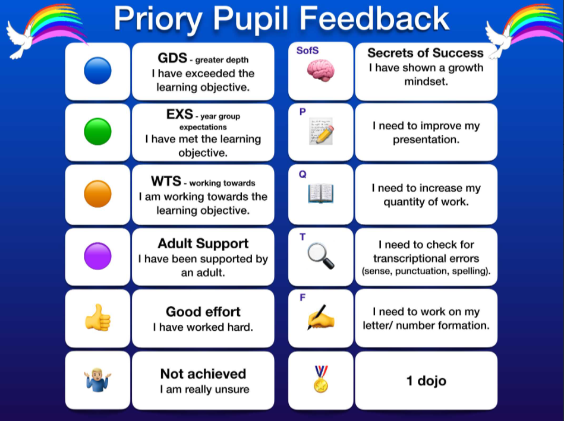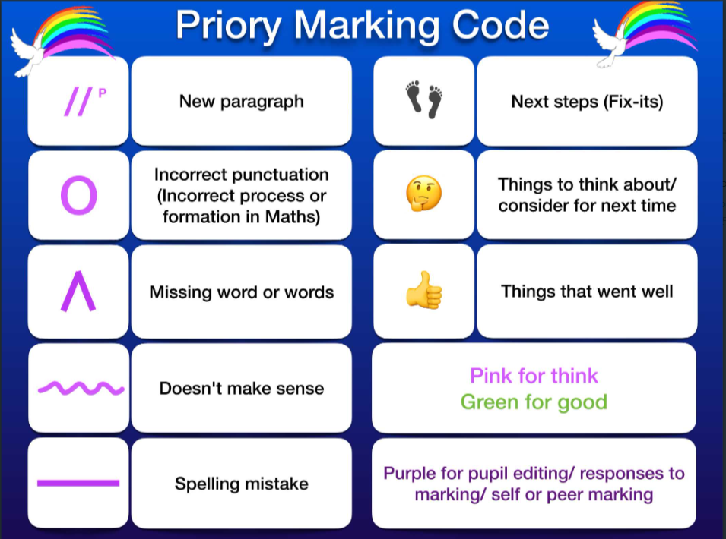
Appendix 2.

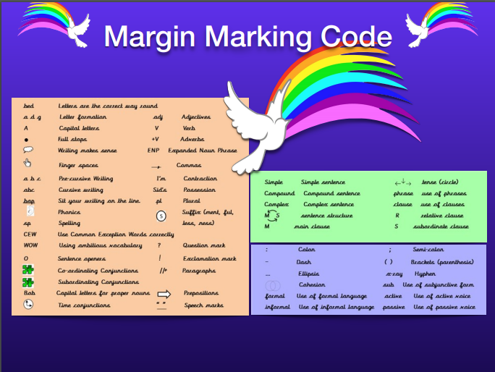

Appendix 3:

Subject | Showbie Feedback | Summative Assessment
English | Lesson feedback using emojis and marking codes  Voice notes and written comments as necessary  Self-reflection emojis/ comments/ voice notes  Targeted use of ‘Reflect time’ | Writing:  Written pieces with Success Criteria  Diagnostic Assessment  Literacy Gold  Spelling Assessments  Reading:  Star Reader  RWI Assessments  Literacy Gold  Assessments (SATs & NfERs)
Maths | Lesson feedback using emojis and marking codes  Voice notes and written comments as necessary  Self-reflection emojis/ comments/ voice notes  Targeted use of ‘Reflect time’ | Assessments (SATs & NfERs)  Star Maths  Arithmetic Champions  Times Tables Champions  Rapid Recall/ Numbots/ TTRS
Science | Lesson feedback using emojis and marking codes  Voice notes and written comments as necessary  Self-reflection emojis/ comments/ voice notes  Targeted use of ‘Reflect time’ | End of unit evaluation of cumulative quizzes  End of unit Socrative Assessment
History | Lesson feedback using emojis and marking codes  Voice notes and written comments as necessary  Self-reflection emojis/ comments/ voice notes  Targeted use of ‘Reflect time’ | End of unit evaluation of cumulative quizzes  End of unit Socrative Assessment
Geography | Lesson feedback using emojis and marking codes  Voice notes and written comments as necessary  Self-reflection emojis/ comments/ voice notes  Targeted use of ‘Reflect time’ | End of unit evaluation of cumulative quizzes  End of unit Socrative Assessment
Design and Technology | Lesson feedback using emojis and marking codes  Voice notes and written comments as necessary  Self-reflection emojis/ comments/ voice notes  Targeted use of ‘Reflect time’ | End of unit summative evaluation  End of unit Socrative Assessment
Art and Design | Voice notes and written comments as necessary  Self-reflection emojis/ comments/ voice notes  Targeted use of ‘Reflect time’ | End of unit summative evaluation  End of unit Socrative Assessment
RE | Lesson feedback using emojis and marking codes  Voice notes and written comments as necessary  Self-reflection emojis/ comments/ voice notes  Targeted use of ‘Reflect time’ | End of unit Socrative Assessment
PSHE | Self-reflection emojis/ comments/ voice notes | N/A
Computing | Feedback as necessary | End of unit summative evaluation  End of unit Socrative Assessment
PE | Feedback as necessary | End of unit summative evaluation
MFL | Feedback as necessary | End of unit Socrative Assessment
Music | Feedback as necessary | End of unit summative evaluation

