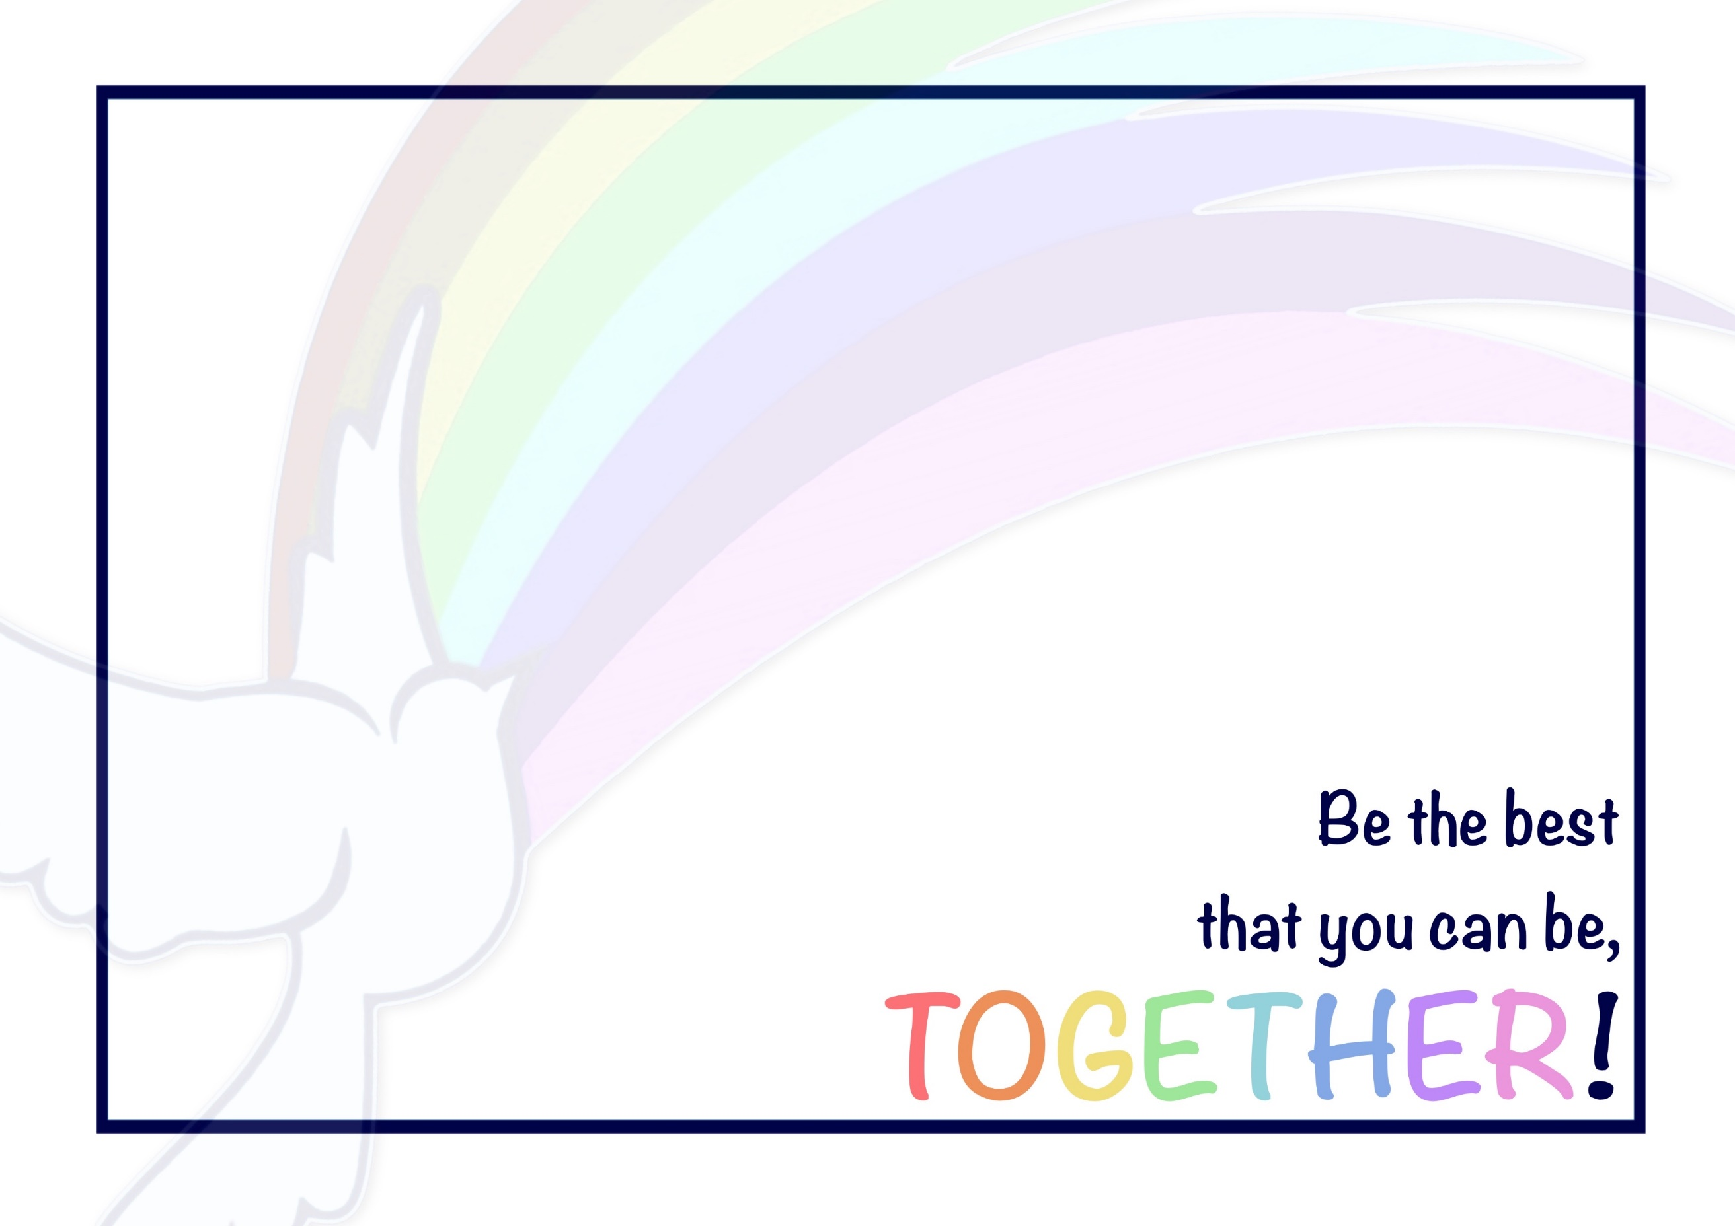
At Priory, we flourish in PE by working TOGETHER!
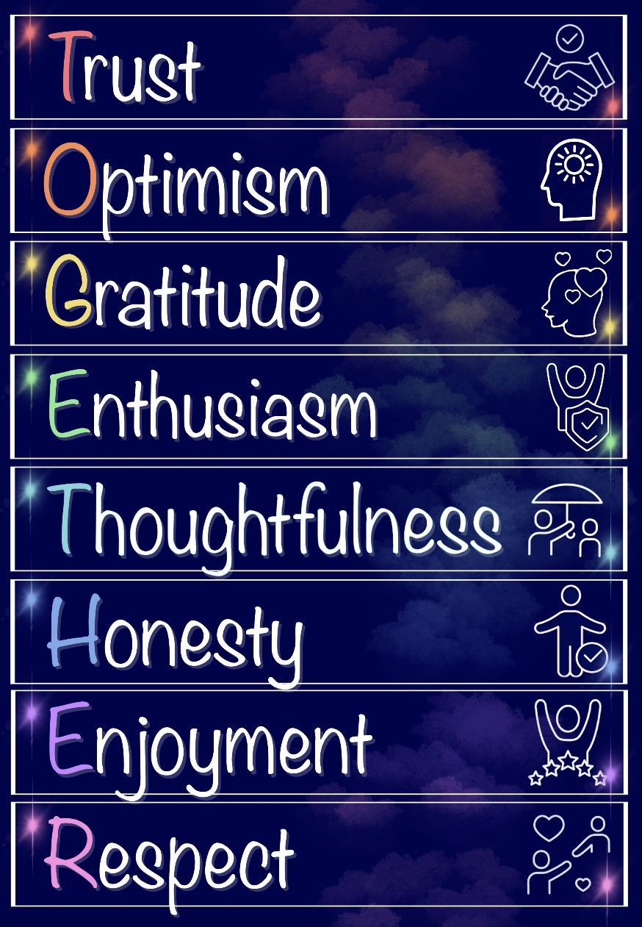
Our Christian Vision and Values underpin everything that we do: they help to guide us in our learning and our life, both now and beyond!

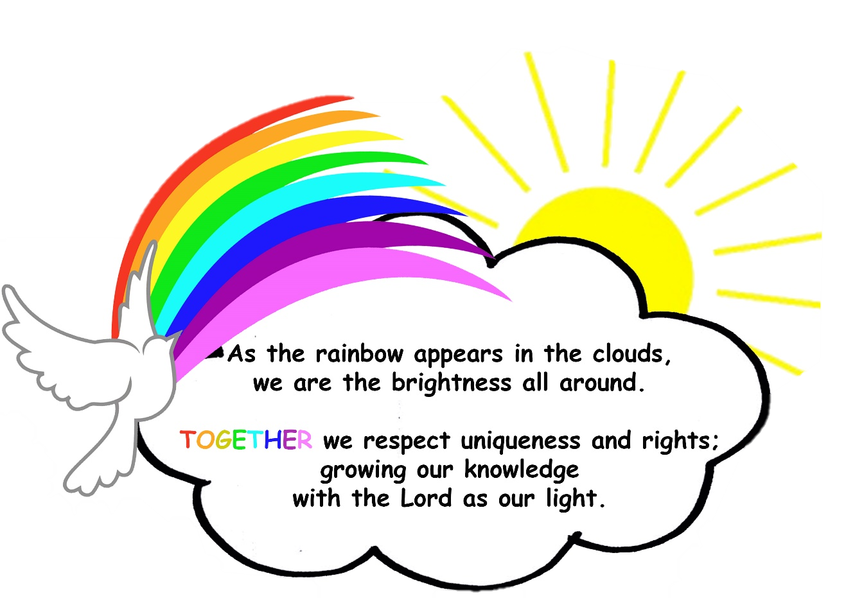

Priory CE Academy Physical Education – Design, Delivery and Outcome Statement

Design (Intent) | At Priory, our aim is that children will develop knowledge that will last a lifetime, along with strong skills to prepare them for the world, enabling them to lead a successful life and make a positive contribution to their community.  Our children are provided with a well taught, knowledge rich curriculum. The basis of this is full implementation of the National Curriculum ensuring breadth, balance and clear progression. Our expectations are high for all pupils: we never narrow our curriculum or deny any pupils the key knowledge taught to the class, unless it is absolutely in their best interest due to a significant learning need.  We carefully consider our children and community to ensure our curriculum is bespoke to their needs. Any purchased schemes are also carefully considered and adjusted to match need. As a Rights Respecting School, where possible in lessons, links are made to the rights of the child. Opportunities to promote British Values, SMSC and our equality objectives are incorporated across the Curriculum. Teachers have strong subject knowledge and learning is clearly sequenced over terms, years and throughout the school to ensure knowledge is learnt and embedded.  Our curriculum is brought to life through the ‘Learning Challenge’ enquiry-based approach. According to cognitive scientists, nothing has been learnt until it is in your long-term memory- we focus on ensuring learning sticks! We understand that through research, what aids long term memory and include these strategies in all our teaching sequences. A focus on key knowledge points for every topic and a clear assessment, away from the point of learning, demonstrates the effective implementation and impact of our curriculum.  We strive in each lesson to put sportsmanship at the heart of our curriculum, applying our school values of TOGETHER!  Through this, we hope to:  • develop children’s self-esteem  • promote mutual respect and to encourage children to work and play freely,  • foster an enjoyment of physical activity.
Design (Intent) | Underpinned by:
Design (Intent) | High expectations:  ‘Be the best that you can be’ is the Priory school motto; like within all aspects of school life and all other subjects, we expect children to live this in PE. We have high expectations for all children in every lesson and use our secrets of success in order to support them and recognise their efforts. | Chronological Understanding:  The curriculum is taught in chronological order in KS2 in order to allow for a deeper understanding of chronology. In Early years and KS1, the children begin from living memory and work backwards in order to understand the past. | Vocabulary:  Pupils at Priory will be taught a variety of vocabulary, which will develop and increase as they move up the school.
Design (Intent) | Evaluating and improving:  Priory pupils will learn how to compare and comment on skills, techniques and ideas that they and others have used. They will be taught how to use their observations to improve their work and performances. | Healthy lifestyle:  Priory pupils will learn the importance of physical activity on their health and be taught to make healthy life choices which will lead to living a healthy and active life. | Wider subject knowledge:  Priory pupils will learn about a particular sporting figure each term within their year band. Allowing the children to develop their general knowledge around subject specific icons- past and present. This will also promote role model, to help drive their ambition within the subject area.  The children will also have the opportunity to take part in a range of subjects, thus giving them the opportunity to develop interests in later life.

Delivery (Implementation) | Lesson Sequence (PE Passport):  The curriculum is planned in well sequenced, progressive lessons. The children will be taught in blocks to immerse them in their learning to enable them to know more and remember more.  The PE scheme of work progressively builds on key knowledge, skills and techniques. Pupils will be taught how to develop flexibility, strength, technique, control, agility, co-ordination and balance. They will be helped to master basic movements including running, jumping, throwing and catching and then given the opportunity to apply these in a range of activities. | Competition (2 and 3) Our pupils have the opportunity to represent the school in a range of physical activities (level 2). Some of these are competitive team or individual competitions and others are festivals or inclusion sports. We encourage our less- active children to become involved as we have A, B and C teams competing in some events and we also take part in an inclusion festival which is a less competitive event with the focus on fun and participation. Our successful sports teams have been frequently involved in county finals (level 3). | Extra-Curricular Activities We offer a range of clubs both during lunchtimes and after school- see PE Passport for a more detailed breakdown.
Delivery (Implementation) | Competition (Level 0 and 1) Priory children are encouraged to work on their ‘personal best’ (Level 0) in a range of PE and sporting activities, including circuit training. Children are encouraged to take part in the Priory Stepping challenge, where classes compete against each other to make the most mount of steps during break and lunchtimes. These are recorded by our Sports Leaders. The pupils are given opportunities for sports competitions on a regular basis (level 1) and this includes intra house competitions in a range of sports- including sports day. | Curriculum:  Classes receive two PE lessons each week.  30 minutes Active time is planned into each day. This will be through Active Learning (that is carried out within other curriculum areas) or through organised Playtime / Lunchtime activities.  PE lessons are fully inclusive with all pupils active and engaged throughout the lesson.  PE lessons are delivered either by the class teacher (following the Scheme of Work).  Curriculum Progression:  EYFS and Key Stage 1 lessons will focus on the development of fundamental movements through multi-skill lessons.  Key Stage 2 planning will focus on revisiting and building on the knowledge, skills and techniques acquired in key stage 1 and applying them across a large variety of sports.
Delivery (Implementation) | Links:  We maintain close links with local clubs and coaches and direct pupils towards them.  - Trentham rugby club  - Stoke city  - Trentham rowing club  - Time4Sport | Active Lunchtimes:  Children have the opportunity to take part in a wide range of activities at lunchtimes which are delivered by our lunchtime supervisors and Sports Leaders.

Outcome (Impact) | The pupils will leave Priory Ce Academy as skilful and intelligent performers. They will acquire and develop skills and perform with increasing physical awareness. They will have the ability to select and apply skills, tactics and compositional ideas to suit activities that need different approaches and ways of thinking. They will set targets for themselves and compete against others. They will understand what it takes to persevere, succeed and acknowledge others’ success. They will take the initiative, lead activities and focus on improving performances. They will have the competence to excel in a broad range of physical activities. They will lead healthy and active lives and make positive life choices. They will have developed positive attitudes to participation in physical activity and embed values such as fairness and respect.
Outcome (Impact) | Swimming Data for 2023/24  National Standard  Pre-35/ 61 = 57%  Post- 49/61 = 80%  Swimming data 2024/25  Upon analysis, 20 children in the year 6 (33%) had very little experience of swimming, having not achieved 10 meters of more before the start of the sessions.  By the end of the sessions, which were focused upon the children who had not achieved their 25 meters, this number decreased significantly with 47.5% of the year achieving 25 meters. | - See Arbour data
Pupil Voice – how can I show this data?
The data gathered annually for this report shows that our pupils:
• understand the benefits of exercise on both physical and mental health.
• have improved fitness levels.
• have a positive and engaged attitude towards PE / physical activity.
• have developed flexibility, strength, technique, control, agility, co-ordination and balance. They have mastered basic movements including; running, jumping, throwing and catching and are able to apply these to a range of sports.
• have taken their interest and enthusiasm for a particular type of sport and continued to pursue it out of school.
• have increased self-esteem through representing the school in competitions and festivals involving other schools.
