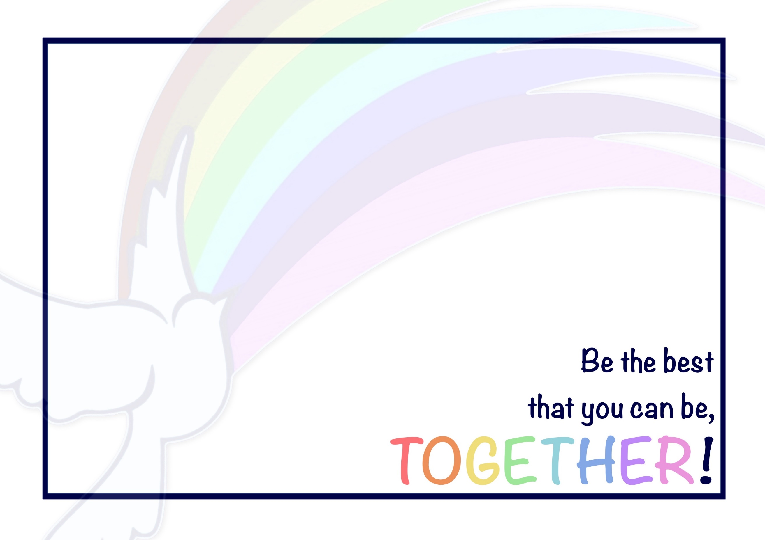
At Priory, we flourish in Early Reading and Phonics by working TOGETHER!
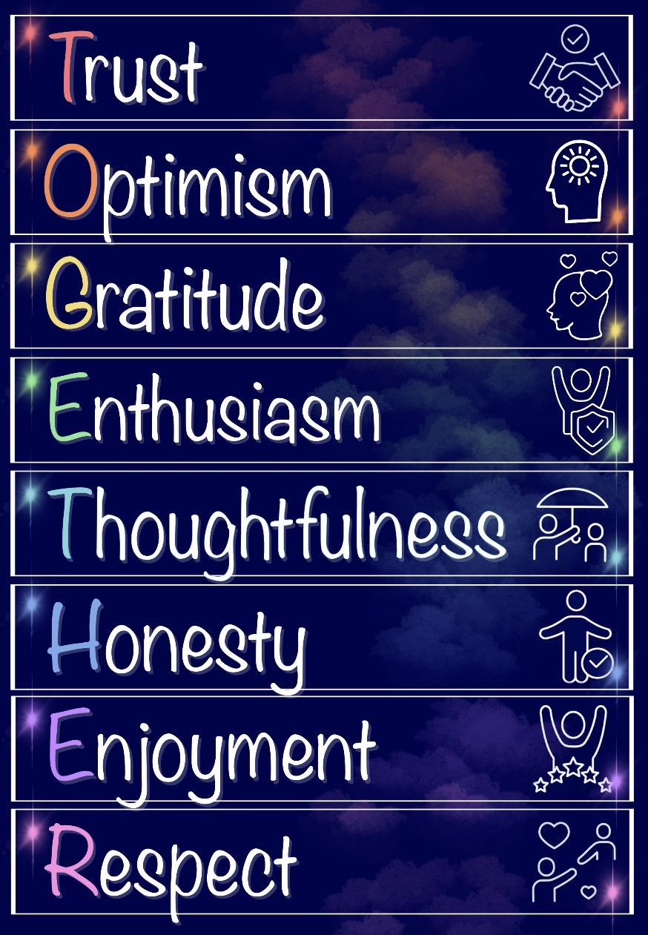
Our Christian Vision and Values underpin everything that we do: they help to guide us in our learning and our life, both now and beyond!

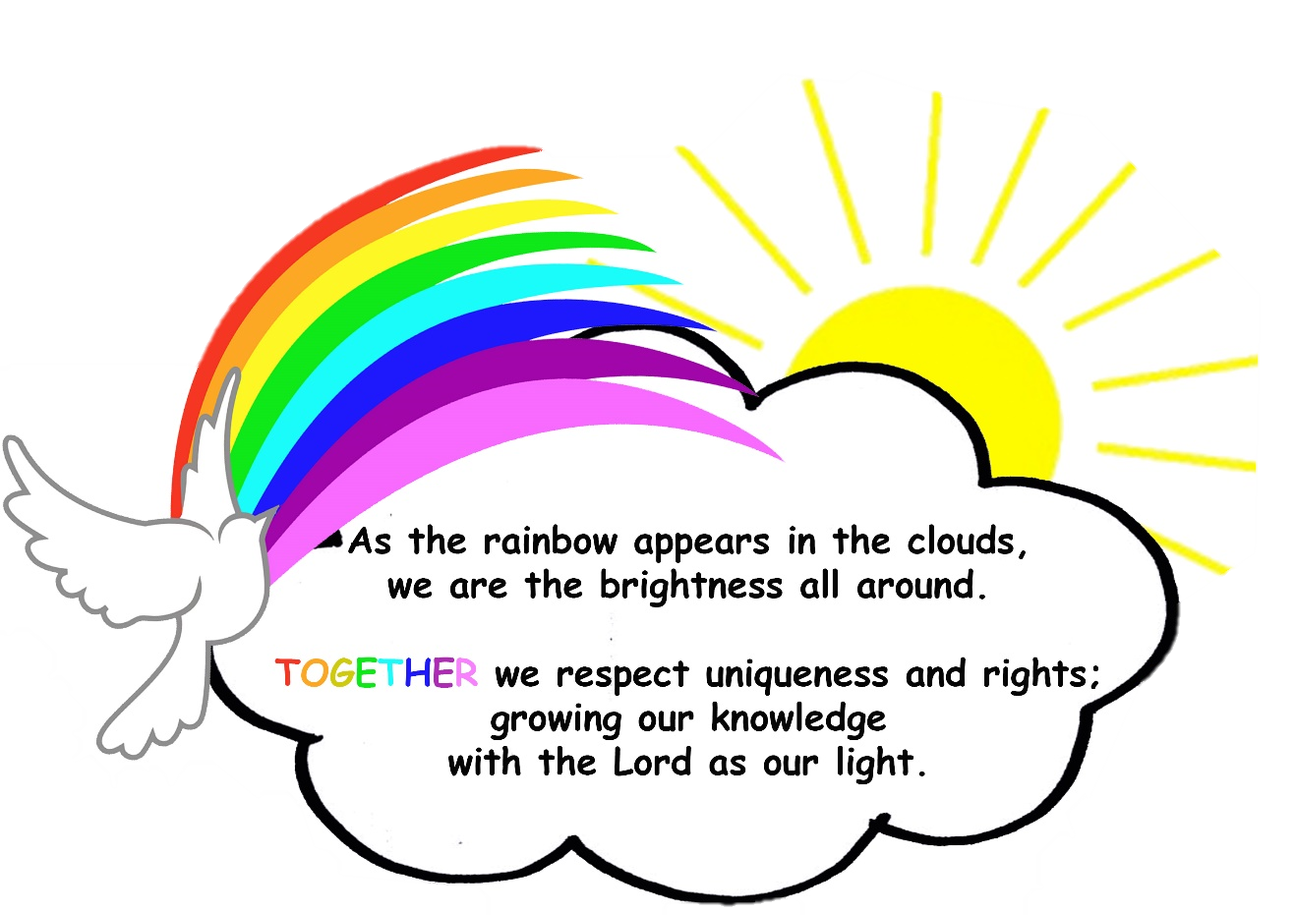

Priory CE Academy – Design, Delivery and Outcome Statement

Design (Intent) | At Priory, our aim is that children will develop knowledge, reading skills and understanding that will last a lifetime, along with strong skills to prepare them for the next stage of their education and the wider world beyond that, enabling them to lead a successful life and make a positive contribution to their community.  Our children are provided with a well taught, sequenced phonics programme that is matched to their ability. The basis of this is full implementation of the RWI programme ensuring breadth, balance and clear progression. Our expectations are high for all pupils: we never narrow our phonics offer or deny any pupils the key knowledge taught, unless it is absolutely in their best interest due to a significant learning need. We put the teaching of reading at the heart of our school and ensure that teachers have the knowledge and determination to teach every child, regardless of age, background or need.  Children should leave Priory with a secure understanding of the basic skills and knowledge required within the EYFS, KS1 and KS2 reading curriculum. They should be fluent readers, that can use their skills to access the curriculum offer and within the community and wider world around them.
Design (Intent) | Underpinned by:
Design (Intent) | High expectations:  ‘Be the best that you can be’ is the Priory school motto; like within all aspects of school life and all other subjects, we expect children to live this in Early Reading and Phonics. We have high expectations for all children in every Phonics/ Reading lesson and use our secrets of success and values in order to support them and recognise their efforts. Teachers give dojos linked to our values as a way to inspire growth and good behaviour for learning. | Teacher Modelling:  Teachers will demonstrate phonetic segmenting and blending (Fred Talk) and RWI specific vocabulary within phonics lessons. They will show the children how to segment and blend to read words and the importance of resilience and perseverance in phonics/ reading.  Teachers will ensure that they model comprehension and how to formulate answers using the text and use sentences stems to develop sentence writing. Teachers will model fluent reading, allowing children to gain an understanding of the text and develop their vocabulary. | Teaching Fluency:  We intend for our pupils to become fluent in their understanding of phonetic concepts. They will be able to develop the fundamentals of phonics through varied fluency questions which will deepen the children’s understanding. Through practise, the children should be able to recall key knowledge confidently. By Friday, children should read their book as a “storyteller” with less reliance on segmenting and blending.
Design (Intent) | Key Vocabulary:  Understanding of key Phonetical vocabulary is vital to success in the subject. Each lesson, specific key vocabulary is taught and referred to throughout. The teacher will demonstrate the importance of the use of the correct vocabulary and will encourage children to use this throughout the lesson and this is encouraged when completing home learning. | Recap and Revise Key Concepts:  New learning should build upon prior learning. It is vital that prior learning is retained. We provide the children with a variety of opportunities to recap phonetical concepts taught in previous lessons, previous terms and previous year groups. We do this at the start of the day, within phonics lessons at our review point, or at any other appropriate times of the day in order to reactivate previous learning and help to commit it into their long-term memory. We call this “Pinny Time”. | Teaching Comprehension skills:  When children have completed the RWI phonics programme, they are then are grouped that has high quality comprehension taught alongside Accelerated Reader.  Promoting a love of reading with Accelerated Reader (AR) can be a highly effective way to engage students, track their progress, and build a deeper appreciation for books. AR encourages independent reading while providing incentives and a sense of accomplishment. This gives students a wide variety of books to choose from. The more autonomy they have over what they read, the more invested they will be in the process.

Delivery (Implementation) | SET 1 ABC.  Speed Sound Lesson:  SET 1 A:  Set 1 Speed Sound Lesson:  - Teach Set 1 Sounds  - Teach Word Time 1.1– 1.3 words – learning to blend  - Spell using Fred Fingers  - Fred Talk.  At the next assessment, children should be able to:  Read most Set 1 single-letter sounds (16 sounds or more).  SET 1 B:  Set 1 Speed Sound Lesson:  - Teach gaps in Set 1 single-letter sounds  - Teach Word Time 1.1– 1.4 - learning to blend  - Spell using Fred Fingers  - Fred Talk.  At the next assessment, children should be able to:  Read most Set 1 single-letter sounds (16 sounds or more)  Blend sounds into words orally.  SET C:  Set 1 Speed Sound Lesson:  - Teach gaps in Set 1 single-letter sounds  - Teach Word Time 1.1–1.5 - learning to blend / blending independently  - Spell using Fred Fingers  - Fred Talk.  At the next assessment, children should be able to:  Read all Set 1 single-letter sounds speedily  Read Word Time 1.1-1.5 words with Fred Talk. | Ditty:  Ditty Speed Sound Lesson:  - Teach Set 1 Special Friends  - Teach Word Time 1.5-1.6  - Review Word Time 1.1-1.4  - Nonsense words (3 sound words)  - Spell using Fred Fingers.  At the next assessment, children should be able to:  Read all Set 1 Sounds speedily, including Special Friends  Read Word Time 1.6 words with Fred Talk  Read 3 sound nonsense words with Fred Talk. | Red:  Ditty Speed Sound Lesson:  - Quickly review Set 1 Sounds (reading)  - Teach Word Time 1.6-1.7 (4 and 5 sound words)  - Review Word Time 1.1-1.5  - Nonsense words (3 and 4 sound words)  - Spell using Fred fingers.  At the next assessment, children should be able to:  Read Word Time 1.6-1.7 (4 and 5 sounds) Phonics Green Words with Fred Talk  Read 3 and 4 sounds nonsense words with Fred Talk.
Delivery (Implementation) | Green:  Set 2 Speed Sound Lesson:  - Teach Set 2 Sounds and corresponding Phonics Green Words  - Review Set 1 and previously taught Set 2 Phonics Green Words  - Nonsense words  - Spell using Fred Fingers.  At the next assessment, children should be able to:  Read the first six Set 2 Sounds (ay, ee, igh, ow, oo, oo) speedily  Read these sounds in Phonics Green and nonsense words with Fred Talk  Read Word Time 1.6 and 1.7 speedily. | Purple:  Set 2 Speed Sound Lesson:  - Teach Set 2 Sounds and corresponding Phonics Green Words  - Review Set 1 and previously taught Set 2 Phonics Green Words  - Nonsense words  - Spell using Fred Fingers.  At the next assessment, children should be able to:  Read the first six Set 2 Sounds (ay, ee, igh, ow, oo, oo) speedily  Read these sounds in Phonics Green and nonsense words with Fred Talk  Read Word Time 1.6 and 1.7 speedily. | Pink:  Set 2/Set 3 Speed Sound Lesson:  - Teach remaining Set 2 Sounds and corresponding Phonics Green Words  - Once confident, teach Set 3 Sounds and corresponding Phonics Green Words  - Review Set 1 and previously taught Set 2 Phonics Green Words  - Nonsense words  - Spell using Fred Fingers.  At the next assessment, children should be able to:  Read the last six Set 2 Sounds (ar, or, air, ir, ou, oy) speedily  Read these sounds in Phonics Green and nonsense words with Fred Talk  Read Word Time 1.6-1.7 and first six Set 2 Sounds in Phonics Green Words speedily.
Delivery (Implementation) | Orange:  Set 3 Speed Sound Lesson:  - Teach Set 3 Sounds and corresponding Phonics Green Words  - Review Set 1 and previously taught Set 2 and Set 3 Phonics Green Words  - Nonsense  - Spell using Fred Fingers (focus on Set 2 Words).  At the next assessment, children should be able to:  Read Set 2 Sounds in nonsense words with Fred Talk  Read Word Time 1.6-1.7 and Set 2 Phonics Green Words speedily. | Yellow:  Set 3 Speed Sound Lesson:  - Teach Set 3 Sounds and corresponding Phonics Green Words  - Review Set 1 and previously taught Set 2 and Set 3 Phonics Green Words  - Nonsense words  - Spell using Fred Fingers.  At the next assessment, children should be able to:  Read first five Set 3 Sounds (a-e, ea, i-e, o-e, u- e) speedily  Read these sounds in Phonics Green and nonsense words with Fred Talk  Read a passage at 60-70 words per minute, attempting intonation. | Blue:  Set 3 Speed Sound Lesson:  - Teach/review Set 3 Sounds and corresponding Phonics Green Words  - Review Set 1, Set 2 and Set 3 Phonics Green Words  - Nonsense words  - Spell using Fred Fingers, support correct grapheme choices.  At the next assessment, children should be able to:  Read all Set 3 Sounds speedily  Read Set 3 Sounds in nonsense words with Fred Talk  Read a passage at 70-80 words per minute, attempting intonation.
Delivery (Implementation) | Grey:  Set 3 Speed Sound Lesson:  • Review Set 1, Set 2 and Set 3 Sounds and corresponding Phonics Green Words  • Nonsense Words  • Spell using Fred Fingers, support correct grapheme choices.  At the next assessment, children should be able to:  Read all Set 3 Sounds in nonsense words with Fred Talk  Read multisyllabic Phonics Green Words speedily  Read a passage at 80-90+ words per minute with intonation that shows comprehension.  AR/ Comprehension:
Delivery (Implementation) | Continued Professional Development (CPD):  At Priory, we are committed to staff development through CPD. This is done by attending training opportunities and regional networking events, in school coaching, PDMs, Visits to others schools to see phonics in action, meetings and support, support from the Trust, etc. | Vocabulary:  At Priory, we have created a vocabulary rich environment. Children from EY through to Year 6 are taught key vocabulary which enables them to develop confidence when reading. Unknown vocabulary within texts is explored during phonics sessions and explicitly taught where needed. | Secrets of Success:  At Priory, we use ‘Secrets of Success’ to support children with their approached to learning: trying new things, improving skills, not giving up, etc. are all recognised as important qualities of effective learners (and therefore, effective readers).

Outcome (Impact) | Outcomes:  We strive for all learners to be at the expected standard at the end of the academic year; with some learners exceeding this and achieving greater depth. For those children who have gaps in their learning, we will support them through phonics lessons and interventions with the aim of narrowing the gap. | Monitoring:  Through coaching, lesson observations, regular group feedback sessions to share ideas and CPD, we recognise that staff are delivering phonics lessons to the children that inspire, challenge and support all learners. The children have opportunities to access the learning at all levels and are becoming confident in their ability.
Outcome (Impact) | Knowledge and Understanding of Phonics/ Reading:  At Priory, the children are continuously developing their knowledge and understanding of Phonics throughout the school day. They can talk confidently and positively about their learning and are keen to share their success. | Application of Reading to the World Around Them:  Children are aware of the importance reading and how reading is a vital, fundamental skill that will allow them access not only to the curriculum, but the world around them. Children know the importance of being actively involved in society, using reading as a lifelong tool to grow knowledge,
