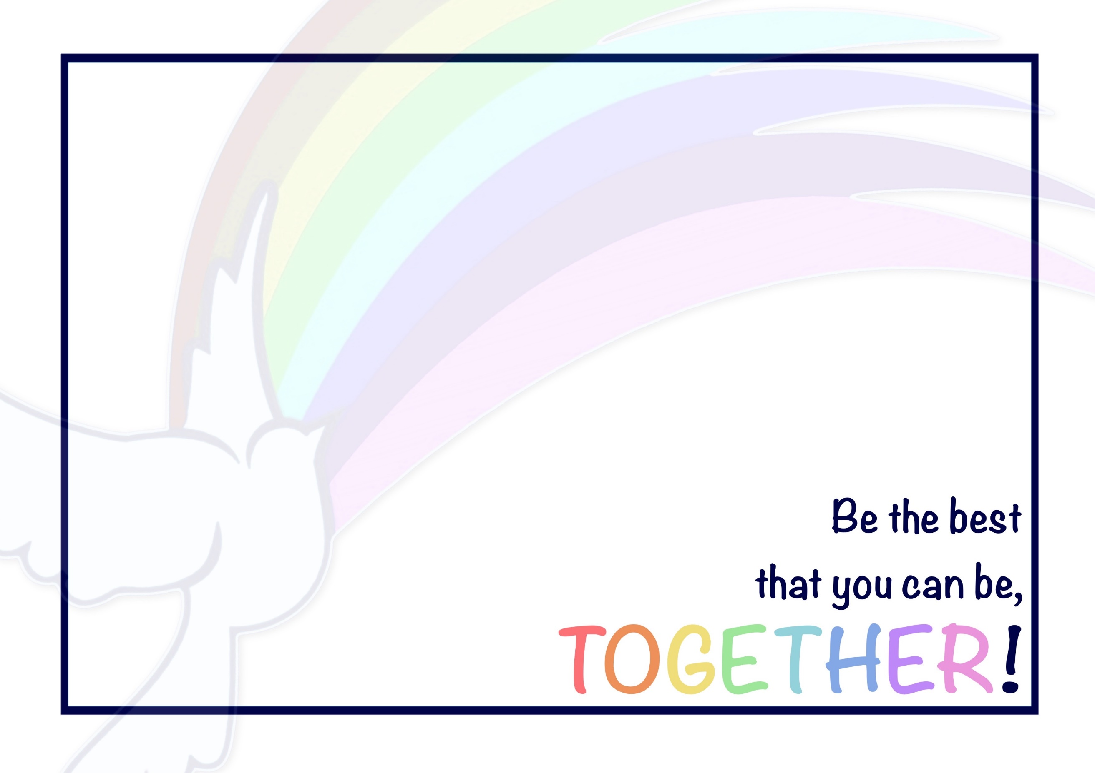
At Priory, we flourish in English by working TOGETHER!
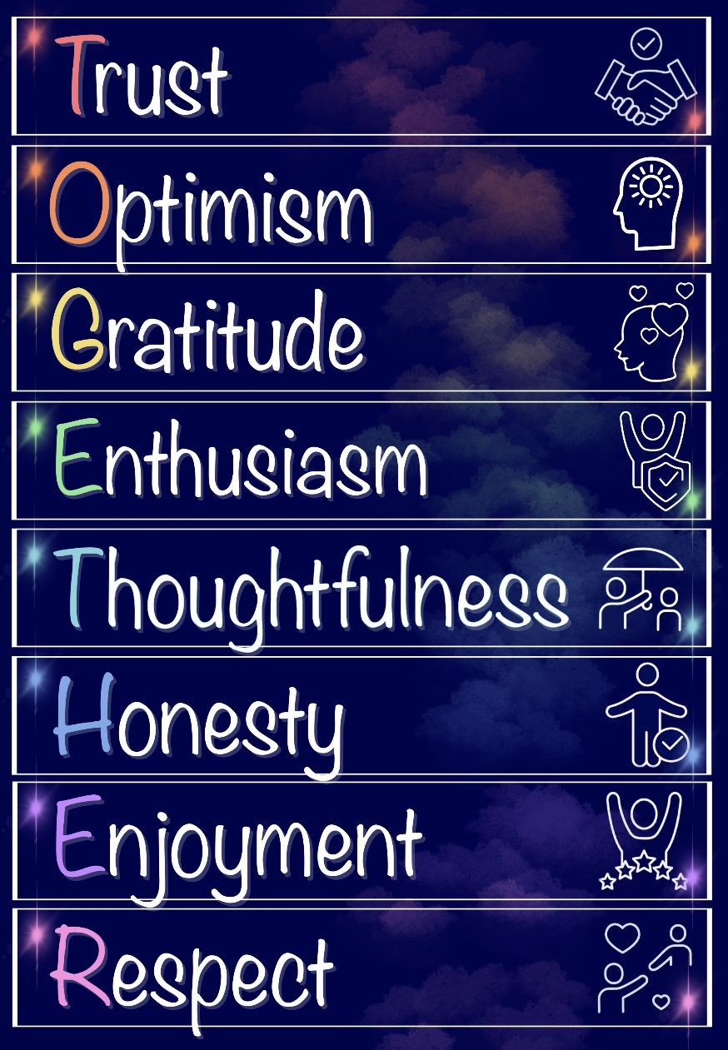
Our Christian Vision and Values underpin everything that we do: they help to guide us in our learning and our life, both now and beyond!

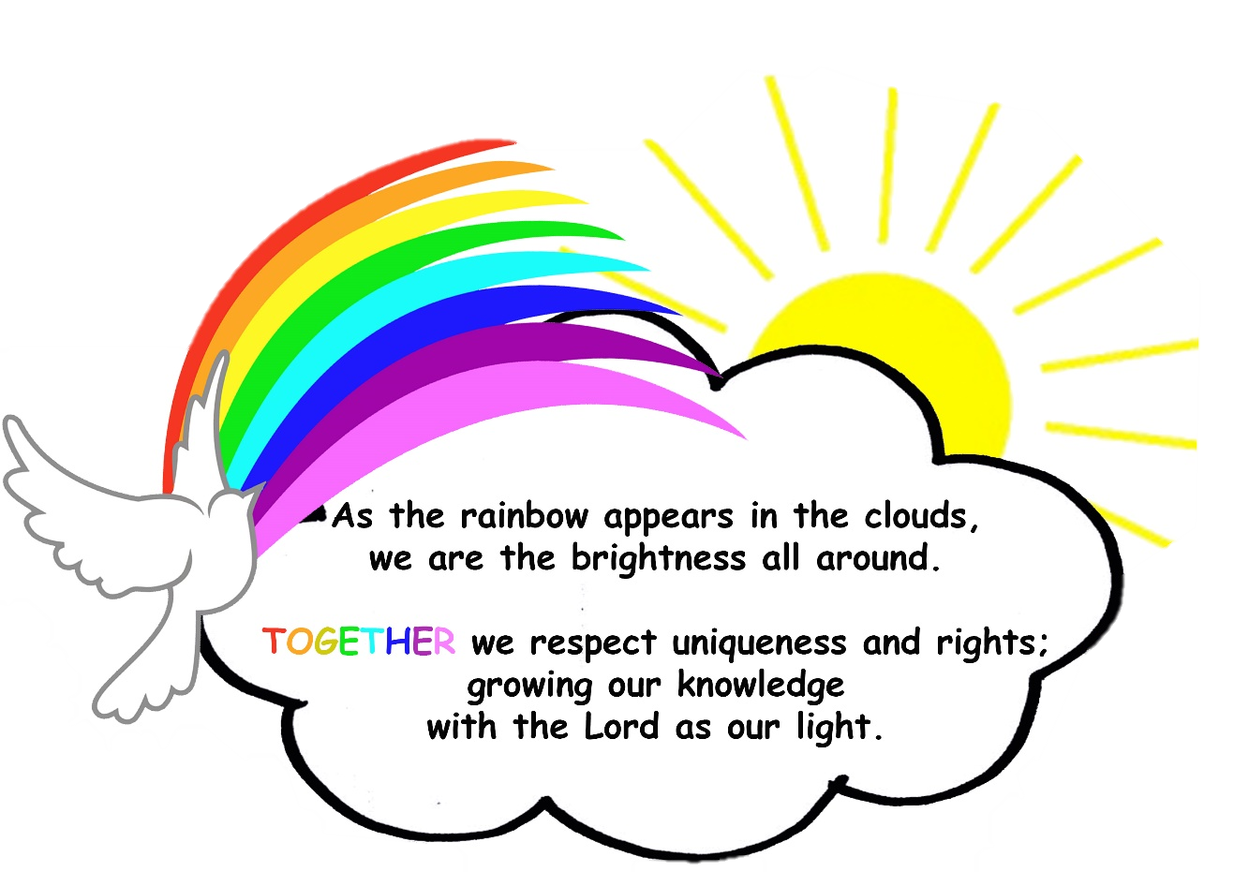

Priory CE Academy English – Design, Delivery and Outcome Statement
Design (Intent) | At Priory, our aim is that children will develop knowledge that will last a lifetime, along with strong skills to prepare them for the next stage of their education and the wider world beyond that, enabling them to lead a successful life and make a positive contribution to their community.  Our children are provided with a well taught, knowledge rich curriculum. The basis of this is full implementation of the National Curriculum ensuring breadth, balance and clear progression. Our expectations are high for all pupils: we never narrow our curriculum or deny any pupils the key knowledge taught to the class, unless it is absolutely in their best interest due to a significant learning need.  Our intention is that children should leave Priory with the key skills and knowledge that will enable them to communicate creatively and effectively through spoken and written language. We want the children to enjoy and appreciate a rich variety of literature, developing a love of reading and the skills to become lifelong learners. Through our ‘High Quality Text’ approach to the curriculum, the children are immersed in a variety of high-quality texts which gives the focus of English sessions context; allowing the children to deepen and embed skills, develop new ones and have the opportunity to apply these skills in a creative way.
Design (Intent) | Underpinned by:
Design (Intent) | Grammarsaurus:  Our English curriculum is delivered through the Grammarsaurus 3D curriculum. This provides the children with a knowledge rich curriculum that covers all of the National Curriculum objectives, ensuring breadth, balance and clear progression. It is bespoke to our school and our setting; adjusted to match need. The 3D curriculum ensures that each unit, in each area of learning, is designed to complement current learning or review prior learning. | Vocabulary:  Children will be immersed in a vocabulary rich environment in all areas of the curriculum. Throughout their learning journey, the children are purposefully exposed to ambitious and high-level text and vocabulary. They are taught the meaning, annunciation and how to use and apply the vocabulary in a range of contexts. This enables them to develop the confidence to use language accurately and creatively. | Texts:  Throughout their learning at Priory, the children will be exposed to a wide variety or texts from different genres, cultures and a range of authors. Texts are carefully selected to provide children with opportunities to experience high-quality vocabulary, a range of authorial styles and different purposes of writing.
Design (Intent) | Questioning:  Learning at Priory, is rooted in questioning that the children build upon to further their understanding. Children are encouraged to ask questions, which can be further investigated and fuel their love of learning. | Recap and Revise Key Concepts:  New learning should build upon prior learning. It is vital that prior learning is retained. We provide the children with a variety of opportunities to recap concepts taught in previous lessons, previous terms and previous year groups. We do this at the start of the day, within English lessons, or at any other appropriate times of the day in order to reactivate previous learning and help to commit it into their long-term memory. | High expectations:  ‘Be the best that you can be’ is the Priory school motto; like within all aspects of school life and all other subjects, we expect children to live this in English. We have high expectations for all children in every English lesson and use our secrets of success in order to support them and recognise their efforts.

Delivery (Implementation) | Place Value of Punctuation and Grammar (PVPG):  At the start of each academic year, writing is taught through the understanding of the ‘Place Value of Punctuation and Grammar’ to secure sentence structure: ensuring that the children have an understanding of the fundamentals of what a sentence is and how to construct one. Once the children have these foundations of writing, then they can explore the different grammatical features and how to manipulate them for effect in their writing. | Writing:  In the Foundation Stage, our children follow ‘The Write Stuff’ approach to writing. This scheme supports the children at the beginning of their writing journey to develop an understanding of text and how it can be used to share information with a reader.  Every class from Year 1 to Year 6 follow the Grammarsaurus approach to writing. At the beginning of the year, the children are taught PVPG to embed their grammar knowledge before moving on to extended writing. This is mapped across our key stages to ensure progression. In Autumn 2, our writing journey commences. This journey exposes the children to text types, genres and story structures in different year groups; recapping and building upon previous skills: text-type specific features, grammar, punctuation and syntax. Units generally last three weeks and can consist of a diagnostic task, text deconstruction using a model text, and contextualised teaching of grammar, punctuation and spelling based upon gaps identified from assessment for learning. In addition to this, the explicit instruction of grammar, punctuation, spelling and syntax is delivered as prerequisite learning within each unit. Writing is then organised into sections and children use this application opportunity to cohesively organise new and existing grammar, punctuation, spelling and syntax learning. Children are taught to edit and redraft their work. |  | Systematic Synthetic Phonics (SSP):  At Priory we follow the Read, Write, Inc. (RWI) scheme of work for the delivery of SSP. It encompasses and promotes accuracy, automaticity and prosody. We use a phonics first approach. We systematically teach phonics, helping children to decode words quickly and accurately. This is the foundation for fluent reading. Children then begin to blend and segment, recognising words automatically, then moving to Speed Sound Sets (basic sounds, more complex sounds, advanced sounds). Mastery of these sounds ensures children are exposed to and can tackle a wide variety of words. Ability matched storybooks are used which have repeated patterns and high-frequency words to develop fluency and confidence and ensure fidelity to the scheme. Children are encouraged to partner read, Fred Talk, question word meaning and to know words on sight to become fluent, confident readers by the end of KS1.
Delivery (Implementation) | Reading:  Once the children have completed WRI they move on to Accelerated Reader (AR). This system identifies the children’s level of reading and provides them with a range of books to develop and challenge their reading ability.  Reading comprehension is taught through ‘Comprehension Crushers’ from Grammarsaurus. This covers whole class reading: focussing on reading fluency and intonation. The children are taught how to comprehend the text; looking at different question styles. Each text includes high-frequency words and a range of common exception words, enabling children to read aloud and understand the meaning of new words they encounter through repeated reading of the text, contiguous reads, echo reads, and the use of the fluency grid. Children should continue to read and discuss an increasingly wide range of fiction, poetry, plays, non-fiction and reference books or textbooks.
Delivery (Implementation) |  |  |  | Handwriting:  Children are taught letter formation through WRI. Once children complete the scheme they move on to learning cursive handwriting through Letter Join. Each class will have an adapted version of the scheme, that meets the needs of their class (teachers can tweak and adapt as the year progresses, again based upon their cohort).
Delivery (Implementation) |  | Spelling:  Once children have completed WRI they move on to Spelling Shed scheme of work for spellings. During these lessons the children learn the spelling rules, apply them to a range of words, as well as the etymology and morphology of words.
Delivery (Implementation) | Continued Professional Development (CPD):  At Priory, we are committed to staff development through CPD. This is done by attending training opportunities and regional networking events, in school coaching, Grammarsaurus, Core 4 English meetings and support, support from the Trust, etc. | Intervention:  ‘Keep up, not catch up’: we endeavour to engage and involve all children within main class teaching and year group specific learning. We scaffold learning as appropriate in order to support this through workshops, and we also use targeted interventions within ‘Basic Skills’ time.  If children do need a little extra support, we use targeted interventions to fill any gaps in prior learning, along with a number of resources that offer targeted support.  Interventions include RWI group work and 1:1. We also use Literacy Gold. |  | Celebration:  The children take part in a yearly World Book Day celebration, where they have the opportunity to engage in a range of reading activities. We also celebrate reading with ‘Crack the Code’ and ‘Word Millionaire’. For spellings the children can earn Royal Bee status.  Through the Trust we participate in a range of competitions and challenges, celebrating the children’s achievements and talent.
Delivery (Implementation) | Assessment:  Staff at Priory continuously monitor pupils’ progress against the attainment for their age. Formative and summative assessments are used to inform planning to ensure gaps in learning are narrowed and that we are providing excellent provision for every child.  Each term, all year groups complete a set of NfER assessment. These are used for a number of reasons: to develop children’s confidence when applying their skills; to back up the teacher’s assessments; to prepare all for the Year 6 SATs.  In KS2, children also complete a termly ‘Star Reader Assessment’: these provide children with a ‘Reading age’, highlight and gaps in learning and support teachers in targeting reading provision. |  |  | Secrets of Success:  At Priory, we use ‘Secrets of Success’ to support children with their approach to learning: trying new things, improving skills, not giving up, etc. which are all recognised as important qualities of effective learners (and therefore, effective readers and writers).
Delivery (Implementation) |  | Reading Rewards:  Crack the Code - Children are expected to read at home at least three times a week. Once this expectation is achieved, children in KS1 on the WRI programme are invited to crack the code on the lock box. Once children are on the AR system, they try to crack the code for each 100% pass rate they achieve on a book quiz. If they successfully open the box, the children are rewarded with a book of their choice, a certificate and a sweet treat to enjoy.  Word Millionaire – through the AR system word counts are tracked from each book quiz the children pass. Various milestones are celebrate to encourage reading stamina as the children strive to achieve word millionaire within the academic year.
Delivery (Implementation) |  |  |  | Recapping Previous Learning:  During ‘Start of the Day’ activities, children complete a range of grammar tasks, including: recap of previous learning and activities to close the gaps. These allow our children to practice the skills previously taught with additional support and guidance where needed.  We also use Fix its (correcting misconceptions or building upon learning in the previous session) and KKPS (Key Knowledge Point – questions that target specific concepts that are not currently the focus of teaching) in order to support the retention and development of knowledge and skills.
Delivery (Implementation) | Reading Areas:  Classrooms throughout the Foundation Stage and Key Stage 1 all contain a reading area to promote a love of reading.  We have 2 central areas for access to reading books: the Learning Zone, which contains books that are part of our AR scheme and the Library, which the children can access for reading for pleasure. These ventral areas are supported by a group of children as librarians and book monitors with the role of organising the areas and supporting other children to access them appropriately.
Delivery (Implementation) |  | Cross-curricular:  Reading and writing, in collaboration with aspirational vocabulary, are taught during English lessons with the intention that skills acquired are then transferred to other subjects across the curriculum. Vocabulary is explicitly taught across the curriculum.
Outcome (Impact) | Outcomes:  We strive for all learners to be at the expected standard at the end of the academic year; with some learners exceeding this and achieving greater depth. For those children who have gaps in their learning, we will support them through lessons and interventions with the aim of narrowing the gap. |  | Monitoring:  Through book shares, coaching and lesson observations, we recognise that staff are delivering English lessons to the children that inspire, challenge and support all learners. The children have opportunities to access the learning at all levels and are becoming confident in their ability.
Outcome (Impact) | Pupil Voice:  Through discussion and feedback, children talk enthusiastically about reading and different genres of writing, thus understanding the importance of this subject. In addition, they can talk about books and authors they have enjoyed, can make connections with their own experiences, and make reading recommendations. |  | Evidence In Knowledge:  Pupils can make links between texts and the different themes and genres within them. They can recognise similarities and differences. Children understand the reading and writing process.
